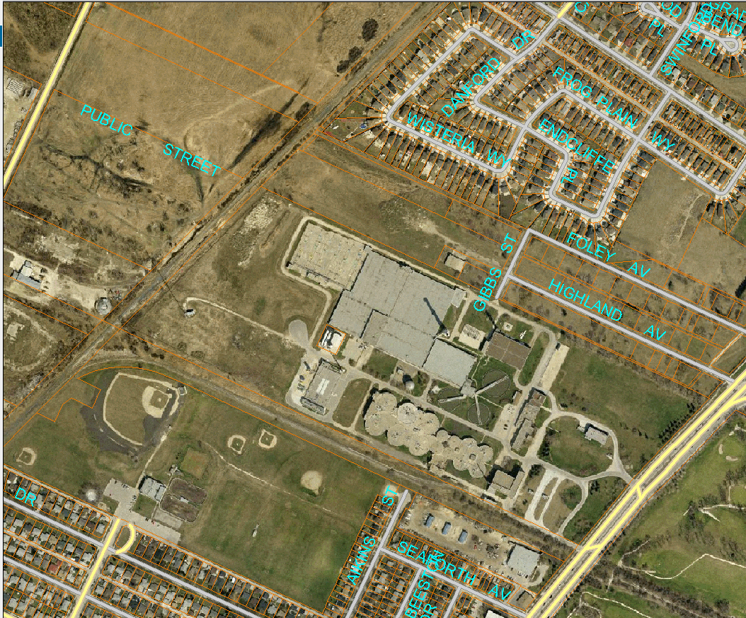
Drawing 1
LOCATION OF SURVEY MONUMENTS
Proposed Monument location
PARCEL 1
MAIN STREET
PARCEL 2
FERRIER STREET

